Introductory Photoshop for Photographers & Artists

Instructor: Tom Klare
trklare@gmail.com
www.tomklare.com
@klaretr

Workshop Overview:
In this hands-on workshop, you will use your own laptop and software to learn the basics of photographic post-production workflow using Adobe Photoshop.

PART 1: PHOTOSHOP BASICS
- How to reset Photoshop defaults:
  - Make sure Photoshop is not running
  - Hold down these 3 keys, then click Photoshop icon:
    - Mac: Shift + Option + Command
    - PC: Shift + Ctrl + Alt
    - When alert box appears, release the keys and click Yes
    - 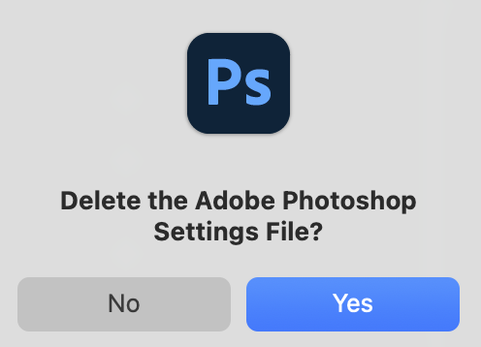
  - Home Screen has different options for creating a new document or opening an existing document/image
    - Open Butterfly.jpg using one of the available methods

- Turn OFF the following Photoshop functions:
  - Click on the Move Tool > Tool Options Bar
    - Uncheck Auto Select
    - Uncheck Show Transform Controls
    - Gear > Uncheck Show layer bounds on hover, Uncheck Show hover bounds from Layers
  - View > Uncheck Snap (in Menu Bar)
  - View > Show > Uncheck Smart Guides (in Menu Bar)
  - View > Show > Uncheck Pixel Grid
  - View > Uncheck Show Extras
  - Hide the Contextual Task Bar (option appears within the 3 dots •••)
  - Photoshop > Settings > General > Uncheck Auto show the Home Screen
  - Tools > Uncheck Show Rich Tooltips, Show Transformations Values: Never > OK

- Photoshop Interface:
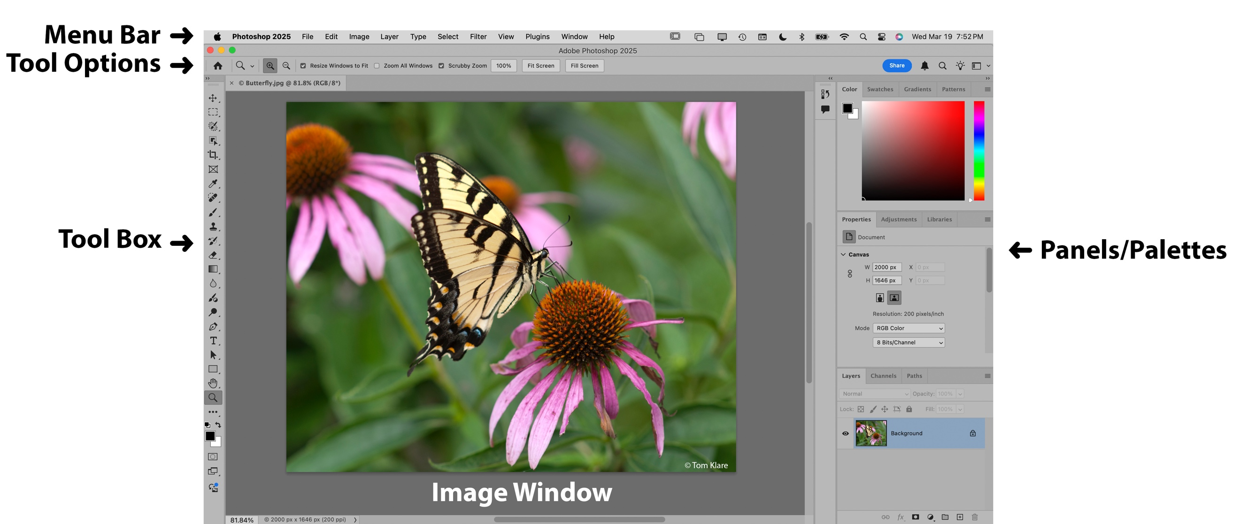

- Drop-Down menus are located in the upper right corner of each Panel/Palette. They contain options specific to the Panel/Palette.

- Simplify interface by hiding the Panels you won't be using:
  - Comments, Color, Swatches, Gradients, Patterns, Libraries, Paths

- Open 2 more files:
  - File > Open > Beach.jpg
  - File > Open > Horse.jpg
  - They will appear as tabs
  - can also be selected in Window menu (bottom of list)

- Screen Modes:
  - F key, View > Screen Mode, or next to last button in tool box
    - Standard
    - Full Screen With Menu
    - Full Screen

- Crop Tool
  - can be used to crop & rotate image

  - Crop Tool options:
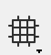
    - Pre-set proportions

    - Grid choices
    - Shield choices

    - delete cropped pixels

- Experiment with different crops

- Take snapshots of different crops in History Palette:

  - Window > History
  - Click camera icon at bottom of History Palette to save snapshot

- To Save: File > Save, or click x on tab and save when prompted

- Photoshop Layers
  - Open Spanish Village.psd
    - Layers on top will be visible above those below
    - Areas with no pixel information are transparent and images on layers below can be seen through them
    - Adjustment layers affect layers below them
    - Layers can be restacked as needed
    - Turn visibility of layers off and on by clicking

- Close all the open documents

PART 2: BASIC OVERALL PHOTO ADJUSTMENTS
- Open the Flash Flood.jpg

- Adjust the tonal range of an image to make it brighter or darker:
  - Create a levels adjustment layer by clicking in the Adjustments panel or the button at bottom of layers palette and choosing the levels adjustment
  - This will make a levels adjustment layer in your layers palette:
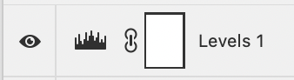

- Click on the Levels adjustment layer and adjust the sliders in the Properties Panel
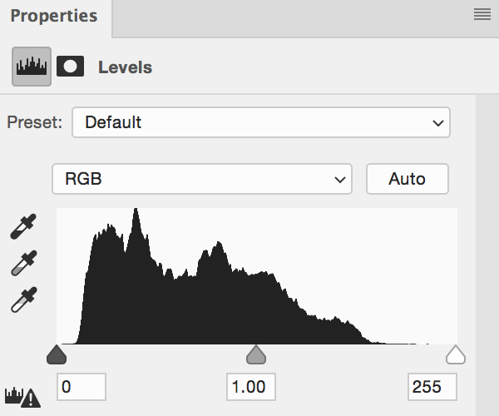

  - The graph represents the histogram of the tones in your image (your camera can also display this during and after shooting)
    - The left side is the amount of dark tones
    - The middle is the amount of mid tones
    - The right side is the amount of light tones
  - Drag the sliders to adjust the brightness and/or contrast of the image
  - Click the eye to turn off and on

- Adjust images using Shadows/Highlights adjustments:
  - Note: Shadows/Highlights is a destructive adjustment when applied to a normal image layer, but is sometimes easier to use than a levels adjustment. It can be used as a “non-destructive” adjustment if the image layer is first converted to a Smart Object so that the adjustment becomes a Smart Filter. To convert the layer, right-click and choose “Convert to Smart Object”
  - Open Tortoise.jpg
    - Right + Click (or Control+ Click) the background layer and choose convert to smart object
    - Image > Adjustments > Shadow/Highlights…
      - Click Show More Options
      - Shadows: Amt = 70, Tone = 35, Radius = 100
      - Highlights: Amt = 0, Tone = 0, Radius = 0
      - Color = 20, Midtone = 0
    - Since the Layer is a Smart Object, the Shadows/Highlights can be readjusted as needed

- White Balance
  - Open Airplane Museum.NEF in Adobe Camera RAW
    - Color > White Balance Tool 
    - Click somewhere in Styrofoam area to sample color that should be neutral
    - Adjust exposure as needed
  - Open Dragon.NEF
    - Color > White Balance Tool
    - Click somewhere in white area of dragon to sample color that should be neutral

- Color Adjustment Layer
  - Open Lightning.jpg
    - Create a Color Balance adjustment layer
      - Cool colors in Midtones and Highlights

PART 3: CONTROLLING ADJUSTMENTS WITH LAYER MASKS
  - Layer masks control what is visible on a layer.
  - Clipping masks enable the pixels or adjustments on one layer to only be visible on the pixel information on the layer to which they are clipped.

- Open Ghost Town.jpg

- Create a levels adjustment layer and lighten landscape area

  - Confine the adjustment to the landscape so it won’t affect the clouds:
    - Click on the white layer mask of the levels adjustment
    - Invert the mask to make it black (Mac: Command + I, PC: Ctrl + I)
    - Use a soft white brush to paint onto the layer mask to allow the adjustment to show only on the landscape
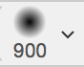
  - Brush Tool:
    - access the controls by clicking dropdown menu in tool options bar

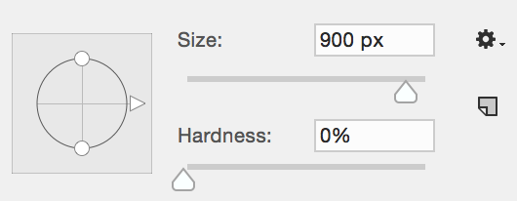
    - brush controls:

    - You can also easily adjust the size of the brush with the [ and ] keys
- Increase the visual impact of sky
  - Click on the Background layer
  - Duplicate the Background layer (in Layer Panel drop down menu choose Duplicate layer)
  - Name it: Sky
  - Click on the Sky layer,
    - Properties Panel > Quick Actions > View More > Select Sky
    - With the marching ants visible, click the layer mask button to apply layer mask to Sky layer
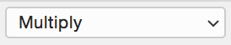
  - Change the blending mode of the Sky layer to Multiply
  - Make further adjustments as desired

- Open the Matillija Poppies.jpg
  - Create a levels adjustment layer and brighten the image a bit without losing detail in the clouds
  - Create another levels adjustment layer and brighten the landscape
    - invert the layer mask and use a white brush to control where the adjustment affects the image

PART 4: WORKING WITH MULTIPLE IMAGES
- Open Luna.psd
  - Select Luna Moth Layer
  - zoom in

- Use Quick Select tool to select the moth as much as possible
  - add or subtract from selection as needed using the lasso tool (Shift to add, Option/Alt to subtract)
  - Apply the selection as a layer mask
  - Refine the mask using the brush tool (white to add, black to subtract)

Select Moon layer
  - Use elliptical marquee tool to select moon (hold Shift to keep it circular)
  - In Properties Panel feather the edge slightly

- Flip the moon horizontally to match direction of light on radio dish
  - Edit > Transform > Flip Horizontal
- Rotate Luna Moth and place on moon
- Apply Drop Shadow to moth

- Create a photo filter adjustment layer that only affects the Moon layer. This can be done by using the Moon layer as a clipping mask for the photo filter adjustment layer
  - Select the Moon layer
  - Option + Click the Adjustment Layer Button
  - Check “Use Previous Layer To Create Clipping Mask”

- Change the color of the moon
- Selectively darken the grass below the observatory
  - Create a Curves adjustment layer just above the Background layer
  - Drag the center of the graph down and to the right a bit to darken the image
  - Click on the Curves adjustment layer mask
  - Invert the mask (Command + i)
  - Use a soft white brush to allow the curves adjustment to darken the lower area of the grass

PART 5: OPEN LAB TO WORK ON PERSONAL IMAGES

3_2025

